Programming language (I) – Homework #4
Requirement:
Re-write homework #2. You are required to implement the following function. Please decide the details of these functions by yourselves. (針對作業 2 所完成的程式碼以函式呼叫的方式改寫，盡力使各運算部份獨立成函式，各函式運算不相依，且結果不變，讓程式碼便於閱讀。)

規定流程如下：
- Openfile(…)
(you have to do the error checking to check if the file to be opened exists or not)
2 . Input_file(…)
2.1 Read_a_paragraph(…).
2.1.1 Read_a_line(…)
3. Process_file(…)
3.1 Process_a_paragraph
3.1.1 Process_a_line
4. Output_file(…)
4.1 Output_a_paragraph(…)
4.1.1 Output_a_line(…)
5. Closefile(…)

作業測試文章 input 檔案，請至課程網頁下載。

Due date:
2008.11.12 PM.5:00

下面是個例子：
原本文章如下：(只有左邊邊界對齊)
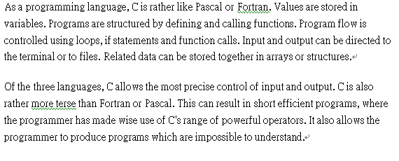
經過程式處理後如下：(左右邊界皆對齊)
